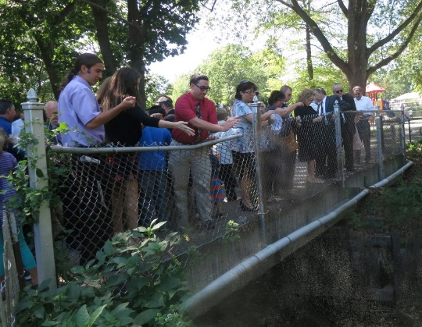
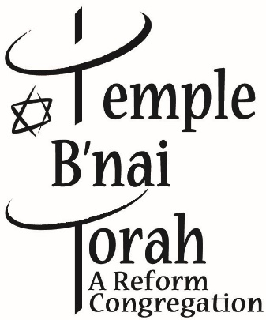

TASHLICH
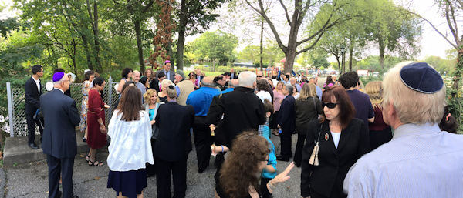
A new year begins with a clean slate
Members of Temple B’nai Torah of Wantagh gathered at Forest City Community Park in the afternoon of the first full day of Rosh Hashanah [last year], to take part in the long-standing Jewish custom of Tashlich. Participants threw bread into the water, to symbolically cast away their sins.
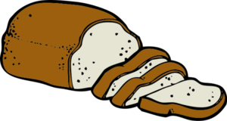
Join us on Thursday September 21, 2017
immediately after services
at Forest City Community Park
DON’T FORGET TO BRING BREAD!!
DIRECTIONS TO FOREST CITY PARK
- From Temple B’nai Torah, cross Jerusalem Avenue and go north on Oakfield Avenue for ½ a mile.
- Turn right onto Barrie Avenue, before the Southern State overpass.
- Make a quick left onto Morgan Drive. Follow Morgan Drive around to the stop sign at Pond Road.
- Turn left on Pond Road and enter Forest City Park.
- We gather at the picnic area.

Questions e-mail - JAB873@aol.com

