Chai Club Program 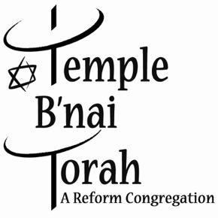 Technology and the Constitution
Monday, December 8, 2025 at 7:00 p.m.
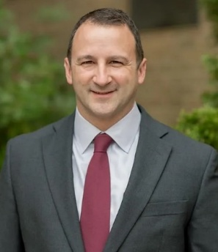
Please join us live at the temple as James Coll will speak to the group about how the Constitution, many of its clauses written in the 18th century, has been applied to new technology. The discussion will include some speculation about how our courts might continue to blend the document’s original text and modern reality in the future.
James Coll is an adjunct professor of American and Constitutional history at Nassau Community College. He has written numerous articles for Politico, The Hill, Newsday and others and is the founder of ChangeNYS.org, a not-for-profit dedicated to promoting honest, open, and responsive government in our state.

All Temple members are invited to this free program!

We will also celebrate December and January birthdays.
Drinks, snacks, and desserts will be served.
Questions? Contact Jay Schoenberg at (516) 476-0989
or Email Jaydiane@yahoo.com
Temple B’nai Torah, 2900 Jerusalem Ave., Wantagh, NY 11793

