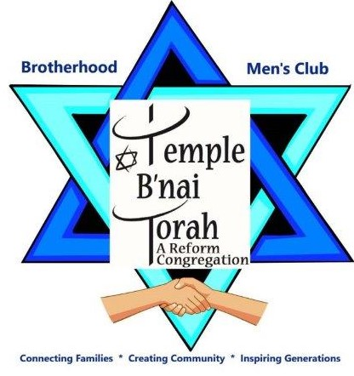
BROTHERHOOD MEMBERSHIP

The Temple B’nai Torah Brotherhood is looking forward to a great 2021-2022. Dues are $45 for the year and entitle you to attend monthly dinners (followed by entertainment), breakfasts on many Sunday mornings, dances, sports activities, softball, yoga, bowling and socialization. Please join us at our get-togethers and keep our Brotherhood a strong and viable arm of the Temple.
MEMBERSHIP for NEW TEMPLE MEMBERS is
FREE for the FIRST YEAR
Make your check out for $45 (tax deductible and includes Men of Reform Judaism membership fee) to Temple B’nai Torah Brotherhood and mail it to Brotherhood, Temple B’nai Torah, 2900 Jerusalem Ave., Wantagh, NY 11793 or drop it off at the Temple office. For more information call Les Richards at (516) 753-4060 or E-mail him at: lesrichards@verizon.net

BROTHERHOOD MEMBERSHIP SIGN UP FORM
NAME ______________________________________________________
ADDRESS __________________________________________________
PHONE – Home ______________________Cell_____________________
E-MAIL ADDRESS ____________________________________________

