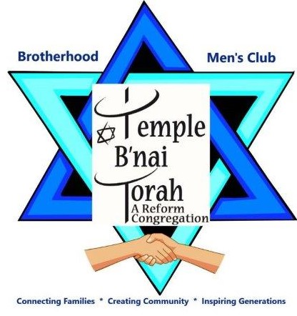
** As a result of the Coronavirus we will not be able to be together in our Temple
until it is socially safe. We hope it is soon and we look forward to sharing Brotherhood/Men’s Club events.

BROTHERHOOD/MEN’S CLUB
of Temple B'nai Torah
is the male arm of the Temple
that includes ALL members
regardless of religious beliefs.

Join us at our dinners once a month with informative NEW programs, breakfasts many Sundays, bowling, yoga. sports activities, dances, and holiday fairs.
Join us for our many fun-filled events.

Brotherhood Membership Form 2020-2021
Name _ _ _ _ _ _ _ _ _ _ _ _ _ _ _ _ _ _ _ _ _ _ _ _
Address _ _ _ _ _ _ _ _ _ _ _ _ _ _ _ _ _ _ _ _ _ _ _
Home phone _ _ _ _ _ _ _ _ _Cell phone _ _ _ _ _ _ _ _ _ _
E-mail _ _ _ _ _ _ _ _ _ _ _ _ _ _ _ _ _ _ _ _ _ _ _ _
2020-2021 dues are only $45
(tax deductible & includes Men of Reform Judaism fee)
Make check payable to: Brotherhood of Temple B'nai Torah
2900 Jerusalem Avenue, Wantagh, NY 11793
(516)753-4060 or e-mail: lesrichards@verizon.net

