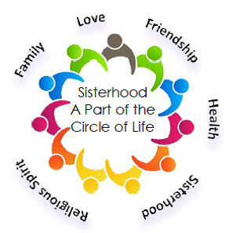

Hi Ladies,

This year we are going to try something new and exciting during our paid-up membership dinner. The dinner is taking place on October 22nd and all Sisterhood members are invited. We would like to extend the opportunity to all of our members to exhibit and/or sell your jewelry, fabric art, painting or other handmade crafts. All that is requested is that you donate one item that will be used for our raffle that is taking place that evening.

We will be setting up tables outside of the social hall for the exhibition from 6:30p.m. until 7:30p.m.

We must hear from you by September 15th so that we can arrange with the office for set up, etc. If you have any questions, please call Emily Altman 516-647-7123.

Below please find a tear off sheet. Please return to either emilysisterhood@gmail.com or place your information in the sisterhood dinner envelope.

Name_______________________________________________________

Cell Phone_________________________________

Home Phone________________________________

Email___________________________________

Item(s) you wish to exhibit or sell__________________________________________________

