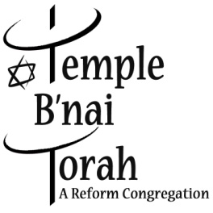
You are warmly invited to join us at our 2016
Tu B'Shevat Seder
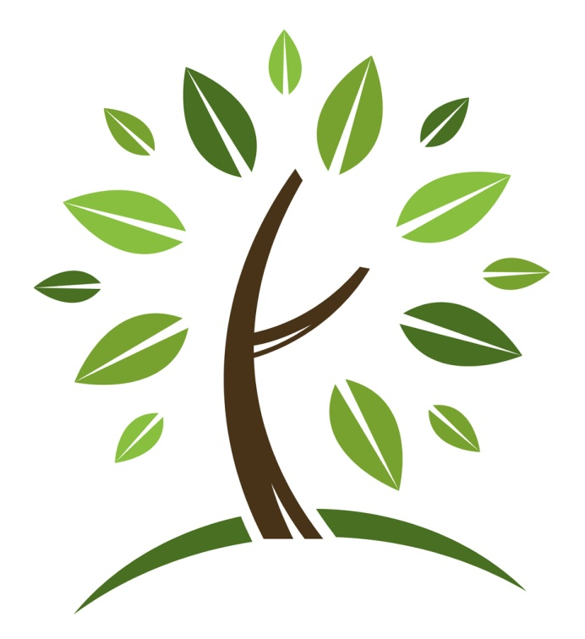
Sunday, January 24 ~ 6:00 pm

Tu B’Shevat or the "New Year of the Trees" is Jewish Arbor Day. It was originally believed to be an agricultural festival, marking the emergence of Spring in Israel. After the destruction of the Temple in 70 A. C. E. this holiday became a way for the Jews to symbolically bind themselves to their former homeland, by eating foods that were found in Israel. In the 16th and 17th centuries Kabbalists created a ritual for Tu B’Shevat similar to a Passover Seder.
There will be a Creative Seder with music and song. Traditional fruits, nuts, and 4 cups of wine/juice will be served as part of the Seder Ritual. Dessert and coffee will be served afterwards. All ages are welcome!
There is no charge for this event. Please RSVP using the form below and return to the main office. *Please note – Nuts will be served at this event.*

Temple B’nai Torah - Tu B’Shevat Seder RSVP Form
Name(s) __________________________________________________________________
# of people attending ____________ Ages of children attending (if applicable) ___________
Phone number ______________________________________________________________
Email address _______________________________________________________________
Temple B’nai Torah ~ 2900 Jerusalem Avenue ~ Wantagh, NY 11793

