Temple B'nai Torah
Chai Club & Circle Of Friends
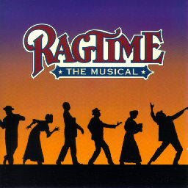

Cordially invite you to join us for
A Day at the Theater
Ticket Cost: $25 Per Person
Payments Due By August 3rd

When: Sunday August 20, 2017
Time: 2:30 pm sharp
Place: BroadHollow at
Elmont Main Stage
700 Hempstead Turnpike, Elmont, N.Y. 11003

We have to commit for these tickets several weeks in advance so we have established a August 3rd date to receive payments for the show. Seating will be assigned in the order payments are received. If there is substantial interest we will try to obtain additional seating, so please get your final reservation in early to avoid being closed out.

Following the show, we will be going to dinner
Arrangements are being made
Questions? Call Pearl at (516) 781-7610
- - - - - - - - - - - - - - - - - - - - - - - - - - - - -
I (we) will be joining the group for Ragtime..

Name(s)______________________________________ Phone________________
I (we) will also be joining the group for dinner. Yes___ No___
Check # ________ Date ____________

Please place tear-off and check made out to TBT Chai Club in an envelope and place it in the envelope on the wall in the TBT office or mail to: TBT 2900 Jerusalem Ave., Wantagh, NY 11793 attn: Chai Club / Circle of Friends Theater Party

