***Temple B'nai Torah***

**Circle Of Friends & Chai Club**

 

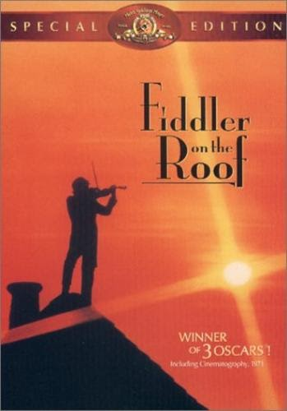Cordially invite you to join us for

A Day at the Theater

**Ticket Cost: $20 Per Person**

**Payments Due By September 18, 2017**

**When:** Sunday October 29, 2017

**Time:** 2:00 pm sharp

**Place:** The Showplace at

Bellmore Movies

222 Pettit Avenue, Bellmore

We have to commit for these tickets several weeks in advance so we have established an August 13th date to receive payments for the show. *Seating will be assigned in the order payments are received*. If there is substantial interest we will try to obtain additional seating, so please get your final reservation in early to avoid being closed out.

Questions? Call Stephanie at (516) 826-8862

* - - - - - - - - - - - - - - - - - - - - - - - - - - - -

I (we) will be joining the group for Fiddler on the Roof

Name(s)______________________________________ Phone________________

Check # ________ Date ____________

Please place tear-off and check made out to TBT Circle of Friends in an envelope and place it in the envelope on the wall in the TBT office or mail to: TBT 2900 Jerusalem Ave., Wantagh, NY 11793 attn: Circle of Friends / Chai Club Theater Party