CIRCLE OF FRIENDS

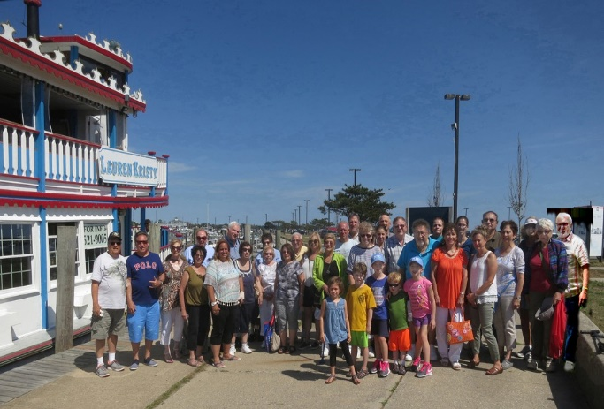
ANNUAL BOAT RIDE – open to all
SUNDAY, AUGUST 13, 2017
11 am SHARP - 2 pm
ON THE LAUREN KRISTY PADDLEWHEEL BOAT
BAYSHORE MARINA

-Fascinating narration on Great South Bay
-Outdoor and large inside shaded area
-Alcoholic and soft beverages for sale
-NO FOOD INCLUDED
-$20 per person (Extra $5 charge for TBT non-members)
-Children welcome (under 12 half price)
-Make this a family affair!
IMMEDIATELY AFTERWARDS

Sergio’s Italian Restaurant
5422 Merrick Rd, Massapequa, NY 11758

$21 pp cash (Members and Non-Members)
Give to Freyda at restaurant
4 course dinner including soft drinks, coffee & dessert

If the boat ride is canceled due to inclement weather,
we will just go to the restaurant at 2:30pm.

Questions? Call Freyda & Warren Kolinsky (516) 242-4282
- - - - - - - - - - - - - - - - - - - - - - - - - - - - - - - - - - - - - - - - - - - - - - - - - - - - - - - - - - - - - - -
I would like to attend this great trip! I will submit check to Circle of Friends by 8/4/17.

Name(s)_______________________________________________

e-mail _________________________________________________
Please provide so that directions can be sent!

Cell Phone_______________ Check #: ________ Amt. of check: ________
Needed for emergency contact morning of event!

# of adults going on cruise: members of TBT______ @ $20 ea.

non-members of TBT______ @ $25 ea.

# of children under 12 going on cruise: ________ @ $10 ea.

# of people going to Sergio’s ______________

