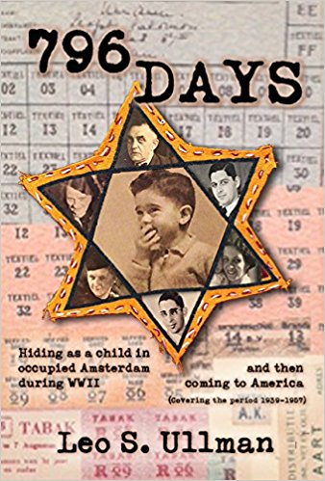
The TBT Sisterhood Social Action Committee is proud to present an inspirational evening with Leo S. Ullman.
Date: Monday, November 6, 2017
Time: 7pm
He will be talking about his book 796 Days: Hiding as a child in occupied Amsterdam during WWII and then coming to America. It’s an incredible story of a family’s survival!
There will be a Question & Answer period afterwards.
No children under 13, please.
Signed copies will be available for purchase before the date of the program, as well as that evening. Checks for $24.95 payable to TBT.
Questions? Call Susan 796-4984 or Andrea 520-6712
Kindly RSVP by Oct. 31st : TBT, 2900 Jerusalem Ave, Wantagh, NY 11793 or place in envelope in office
Yes! I am excited to attend the social action program on November 6th:
Name __________________________
# of people attending _______
Phone #: _____________ Email: ____________________

