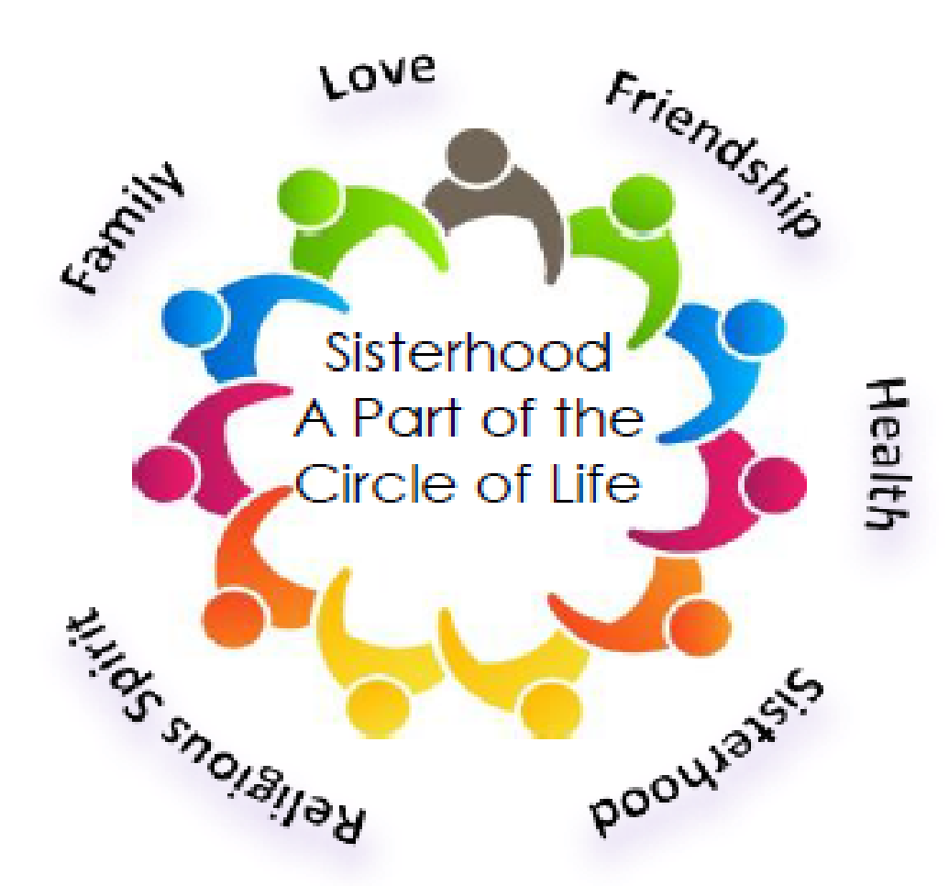

Hello Ladies!

The 2017/2018 temple year is under way and we would like to welcome you to Sisterhood. Our Annual Paid-Up Membership Dinner is Tuesday, October 17 (7:30 P.M. hors d’oeuvres, 8:00 P.M. dinner). This is a lovely evening of fun, friendship, and great food, as well as a wonderful kickoff to a busy year of activities.

If you have already joined Sisterhood, thank you very much. All new TBT women and mothers of children in grades K-2 in the Religious School have a complimentary membership their first year. But, if you have not yet joined, please include your membership check for $40 (payable to TBT Sisterhood) along with your tear-off below.
Sisterhood’s Annual Paid-Up Membership Dinner
Tuesday, October 17, 2017
Hors d’oeuvres at 7:30 P.M. in the Kiddush Lounge
Dinner at 8:00 P.M. in the Social Hall
RSVP by September 26, 2017

Kindly send the tear-off below to:
TBT Sisterhood, 2900 Jerusalem Avenue, Wantagh, NY 11793
or put in the envelope in the temple office.
Please label you envelope: Sisterhood Dinner
Direct your response to the attention of Marlyn Appelt
Questions? Call Marlyn @ (516) 333-7115.

Sisterhood Paid-Up Membership Dinner October 17, 2017

Name ________________________ Phone _________________ E-mail ___________________________

I would like to sit with ___________________________________________________

(Note: Tables seat 8 people comfortably. We will do our best to accommodate requests.)

